**Team Name**: Error Code 42

**Team Leader's name:** Nidhi Kotak

**Team members name:**

Vaibhav Sheth

Mansi Gajwani

Heramb Malbari

**Submission Date:** 08-dec-20

Jackson Fashion Case Study Analysis and Solution

Managing New Normal: Reshaping and Rethinking

**Problem Identification and Statement**

Jackson Fashion is well established retail chain store over the globe with excellent brand image in fashion industry, but the main issue is, inadequate matching of fashion & style with fast fashion consumer’s demand. To support our problem findings, we can see that the shares of the company is not performing well for last 2-3 years. Thus, pandemic is not the only reason the company is not showing sales. Apart from that, Operation cost is also a big issue considering worldwide presence of the company and lack of management in Inventory management and supply chain.

Overall, company’s objective is to increase revenue, reduce operational cost, and identify their core competence.

**Assumptions while solving the Case**

* Target market is Urban and Semi-Urban for the company.
* Jackson Fashion has its store located in all the major metro cities of various nations.
* JF doesn’t have a proactive presence over online market and majority of its revenue comes from Physical stores.
* There is lack of working capital but there is sufficient marketing and advertising budget.
* JF has its own inventories and are not involved in any kind of bonds with third party, hence they can make their own decisions to relocate and/or reshape.

**Analysis of Case Using various Framework**

We have used:

1. Cost Reduction Framework [ For reducing Operational Cost and revenue increment]
2. Growth Strategy Framework [ For Increasing revenue by growth of the company in pandemic]

**Cost Reduction Frame work**

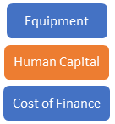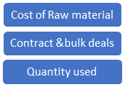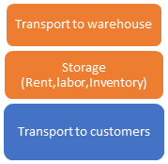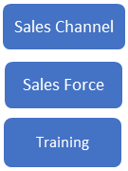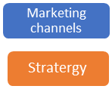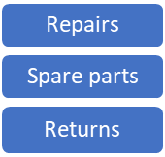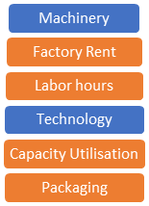

* Highlighted part needs the correction and ultimate reducing the operation costs and helps in increasing the revenue.
* Highlighted parts are the one which can be reduced or reshaped but how? It’s given in the solution part.

**Growth Strategy Framework (To achieve target of 20% growth in sales every year)**

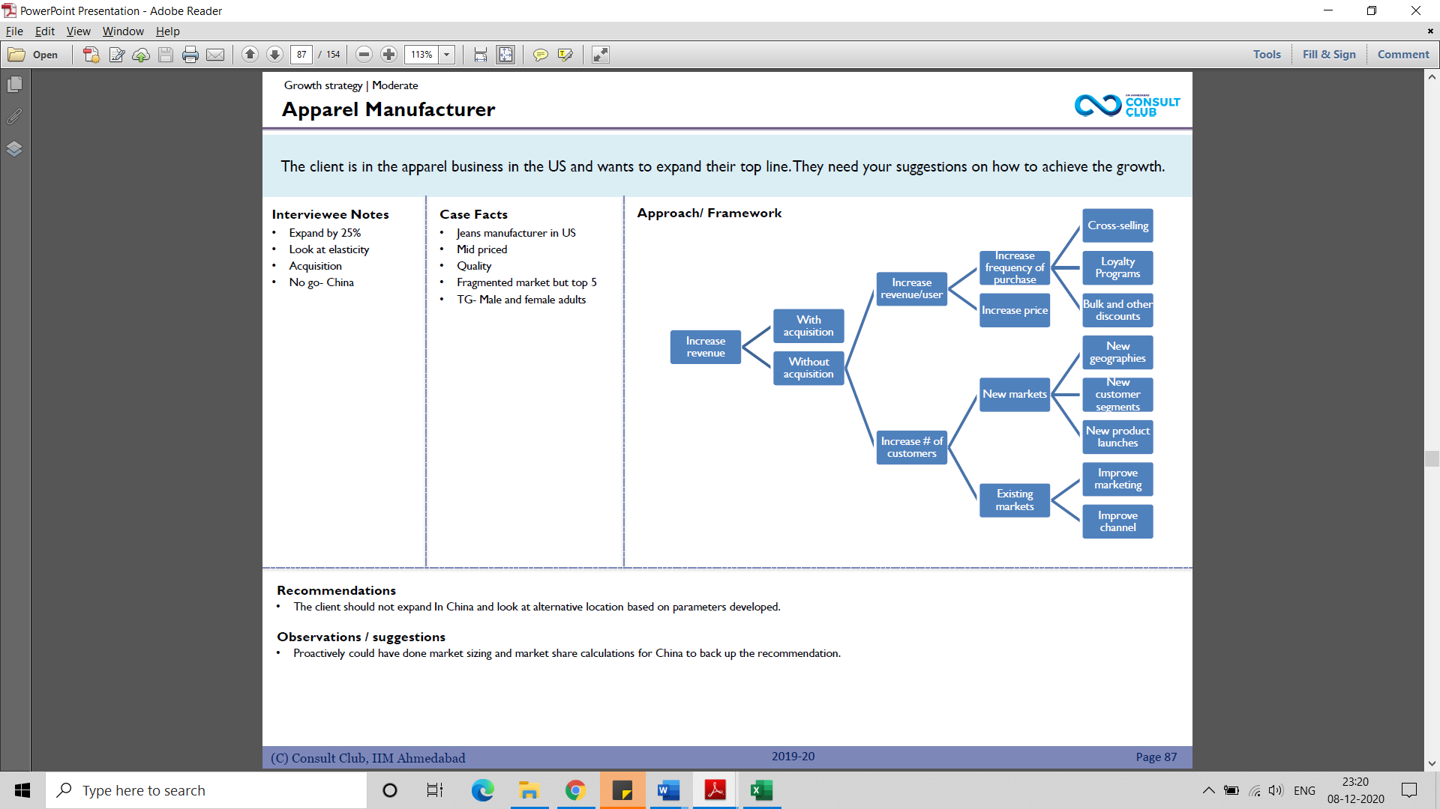

* This is the path a company can choose as working capital is low, we can merge with other company or do any acquisition thus, without acquisition path is the most suitable and illustrated above.
* Further company can’t afford to increase the price thus frequency of buying must be increased.
* New Customer segmentation must be done considering pandemic situation.

**Best Possible Solution**

As per the findings in above analysis we have following solutions

**Marketing segmentations**

1) fully lockdown areas: The stores will be shut here, thus transfer its inventory to pool inventory location

2)semi lockdown: Where only Trendy and Unique fashion will be sold such that customers here have very less time to think for limited access to the shop.

3) open for all with safety precautions: Use marketing such as **Guerrilla marketing, OOH marketing** etc to fetch more and more consumers.

- Highly focus on **Internet marketing** and availability of any good and application of **AI AR VR in shopping experience**.

- Hiring new talents and lay-off old employees with no updated skills.

To use **Pool Inventory** concept

* Which will reduce your operating cost as any 2 geographical location will be selected among the present one and all the rest of the inventory will be shifted here.
* Also, this will be located in the pandemic proof areas which are out of danger zone.

**B-Plan**

* Merger and Acquisitions with local vendors in so as to reach to maximum customers.
* Here we will introduce new product line which will mainly focus on quality and price sensitivity.
* New geography locations where there is high demand in nearby areas.

**Conclusion**

Overall conclusion of the company and its solution is the average growth of the company is getting decrease and to rapidly grow, whole company needs to be restructured. Thus, suggested ways in the study can show you the maximum growth possible. Gradually applying these steps and managerial positions we can achieve our targets in 2 quarters and same way continuing it for next 3 years.

Plans to close 300-400 global stores

Laid of 20% of designers

200 are still closed or under restrictions

Sales recovery in aug2020 – but 25% less

Total sales fell by 16% in 2020

4000 stores worldwide

Deal with sudden emergency, full proof plan

Fitting rooms are closed, litter signs and social distancing announcements

Steep rise in sales online

JF shares was not performing well past 2-3 years

Consumer behaviour – buy clothes at discounted rate

JF cant sell it on discount and tarnish image of the company

Off price strategy

Established in 1990 in spain

Operates in 20 countries

Manufacturing units add upto 250+

16 productions offices and 16 country offices

JF has good budget of advertising

Advertisement should be quality centric

High brand value